**Name: _______________________________**

Orbits and Escape Velocity – Practice

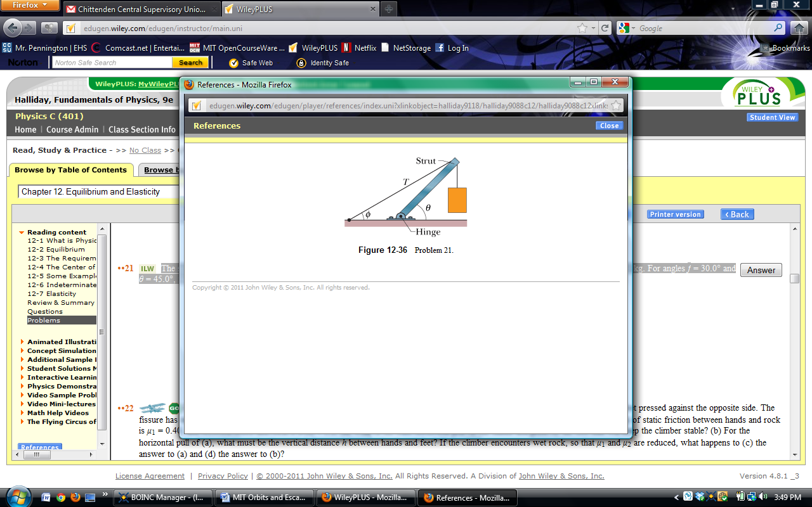

1. A concrete block of mass 225 kg hangs motionless from the end of the uniform strut of mass 45.0 kg. For angles  = 30.0° and  = 45.0°:

A. Find the tension T in the cable.

B. Find the horizontal and vertical components of the force on the strut from the hinge.

2. Miniature Black Holes: Left over from the big-bang beginning of the universe, tiny black holes might still wander through the universe. If one with a mass of 1.0 × 1011 kg (and a radius of only 1.0 × 10-16 m) reached Earth, at what distance from your head would its gravitational pull on you match that of Earth's?

3. We want to position a space probe along a line that extends directly away from Earth toward the Sun in order to monitor solar flares. How far from Earth's center is the point on the line where the Sun's gravitational pull on the probe balances Earth's pull? (MEarth = 5.97 x 1024 kg, MSun = 1.99 x 1030 kg, REarth = 6378 km, REarth-Sun = 1 AU = 1.50 x 108 km)

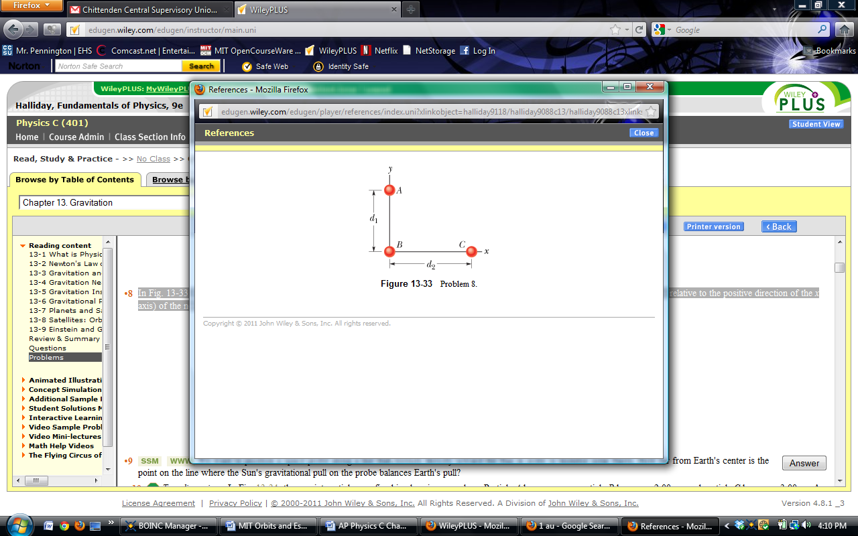

4. Three 5.00 kg spheres are located at distances d1 = 0.300 m and d2 = 0.400 m. What are the magnitude and direction (relative to the positive direction of the x axis) of the net gravitational force on sphere B due to spheres A and C?

5. A particular neutron star is rotating at 1.0 rev/s and has a radius of 20 km. What must be its minimum mass so that material on its surface remains in place during the rapid rotation?

6. A solid uniform sphere has a mass of 1.0 × 104 kg and a radius of 1.0 m. What is the magnitude of the gravitational force due to the sphere on a particle of mass m located at a distance of

A. 1.5 m from the center of the sphere.

B. 0.50 m from the center of the sphere?

C. Write a general expression for the magnitude of the gravitational force on the particle at a distance r ≤ 1.0 m from the center of the sphere.

7. What multiple of the energy needed to escape from Earth gives the energy needed to escape from

A. the Moon? (MMoon = 7.36 x 1022kg, RMoon = 1737 km)

B. Jupiter? (MJupiter = 1.90 x 1027kg, RJupiter = 71,492 km)

8. Asteroid:

A. What is the escape speed on a spherical asteroid whose radius is 500 km and whose gravitational acceleration at the surface is 3.0 m/s2?

B. How far from the surface will a particle go if it leaves the asteroid's surface with a radial speed of 1000 m/s?

C. With what speed will an object hit the asteroid if it is dropped from 1000 km above the surface?

9. Satellite in Earth Orbit

A. What linear speed must an Earth satellite have to be in a circular orbit at an altitude of 160 km above Earth's surface? (MEarth = 5.97 x 1024 kg, REarth = 6378 km)

B. What is its period of revolution?

**Solutions:**

1. A. 6.63 x 103 N

B. Fx = 5.74 x 103 N Fy = 5.96 x 103 N

2. 0.82 m

3. 2.59 x 108 m

4. 2.13 x 10-8 N @ 60.60

5. 4.7 x 1024 kg

6. A. (3.0 x 10-7 N/kg)m

B. (3.3 x 10-7 N/kg)m

C. 

7. A. 0.0453

B. 28.4

8. A. 1.7 x 103 m/s

B. 2.5 x 105 m

C. 1.4 x 103 m/s

9. A. 7.80 x 103 m/s

B. 5.26 x 103 s ( = 87.7 min)